
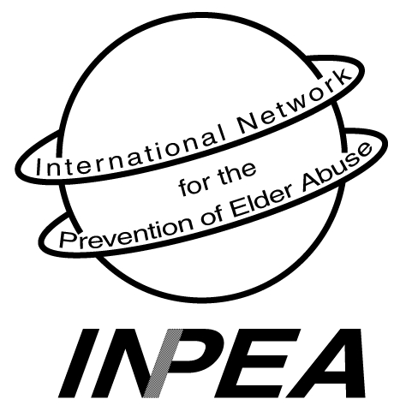

INTERNATIONAL NETWORK for the

PREVENTION OF ELDER ABUSE

Colleagues, February 10, 2006

The International Network for the Prevention of Elder Abuse (INPEA) has launched its research agenda in accordance with recommendations from the Second Assembly on Ageing of the United Nations. The first phase involves an environmental scan. It is being conducted in partnership with Ryerson University, the University of Kentucky and Cleveland State University.

The purpose of this letter is to request your participation in the study to gather information on public policy, services, educational resources, and training available on elder abuse. Our ultimate goal is to identify gaps in the above-mentioned areas and to develop interventions and strategies to fill them.

This survey is the first of its kind and should be completed specifically about elder abuse in your country. It will be translated in French, Japanese, and Spanish. You have been identified as a highly knowledgeable resource, and your participation in this study is valuable and much appreciated. Your involvement is completely optional and voluntary; you may choose to complete the survey, but you do not have to identify yourself on the survey form.

By completing the survey and returning it, you have consented to participate. You may complete the survey individually or convene a working group in order to do so. In any published report, you will not be identified by name, but by country only. Please answer questions to the best of your ability, based on your knowledge and understanding of elder abuse. You do not have to answer particular questions on the survey, if you wish. Participation or non-participation will in no way affect relationships with any of the agencies or entities listed on this cover letter.

Once you have determined the answers to the questions, we anticipate that you will be able to complete the survey in approximately a half hour. For inclusion in our study, please return the survey to the University of Toronto by e-mail, fax, or conventional mail (see instructions below) by March 31st. You may download additional copies of the survey on the INPEA website, www.inpea.net

We anticipate providing feedback on the survey results by summer 2006, which will be posted on the INPEA website. The data will be entered by a graduate research assistant (GRA) at the University of Toronto. The GRA’s work will be completed under the supervision of Dr. Elizabeth Podnieks. The surveys and the resultant spreadsheet will be kept under lock and key in a secure room at the University. Only the GRA, Dr. Podnieks, and the other Investigators listed below will have access to the entered data for the purposes of analysis and report writing.

If there are others to whom the survey should be sent for completion, please send the survey or have them obtain the language-specific survey via the INPEA website and submit it by e-mail, fax, or conventional mail.

We sincerely appreciate your time and contribution to this important initiative. If you have any questions regarding the completion of the survey, please contact any one of the persons listed below.

Thank you,
International Network for the Prevention of Elder Abuse

To complete the survey and return the form by e-mail:
- Open “WorldView Environmental Scan” file
- Fill out answers in shaded areas
- Save to your computer
- E-mail your completed survey to: inpea@ryerson.ca

To return by conventional mail or fax, send to:

WorldView Environmental Scan
c/o David Salib
222 College Street, Suite 106
University of Toronto
Toronto, Ontario M5T 3J1
Telephone: 416.978.0377; Fax: 416.978.4771

Investigators (please contact any one of these individuals should you have questions):
Elizabeth Podnieks, Ph.D., Ryerson University, Canada, Elizabeth.podnieks@utoronto.ca
Georgia Anetzberger, Ph.D., Cleveland State University, ganetzberger@aol.com
Paula Mixson, M.S.W., Texas, paula.mixson@grandecom.net
Pamela B. Teaster, Ph.D., University of Kentucky, pteaster@uky.edu

INTERNATIONAL NETWORK FOR THE PREVENTION OF ELDER ABUSE
222 College St., Suite 106, Toronto, Ontario, Canada M5T 3J1
Tel: 416-978-1716 Fax: 416-978-4771 Email: onpea.info@utoronto.ca
INPEA EXECUTIVES:

PRESIDENT:
Dr. Lia Daichman
Buenos Aires, Argentina
liadaichman@fibertel.com.ar

VICE - PRESIDENT:
Dr. Elizabeth Podnieks
Ryerson University
Toronto, Ontario, Canada
Elizabeth.podnieks@utoronto.ca

SECRETARY GENERAL:
Susan Somers
New York, USA
Sbsomers5@aol.com

TREASURER:
Robert Brand, PhD
New York, NY USA
Brand@fordham.edu

SPECIAL OBSERVER:
Dr. Alex Kalache
World Health Organization
Geneva, Switzerland

SPECIAL ADVISOR:
Dr. Gloria Gutman
Simon Fraser University
Vancouver, B.C., Canada

Dr. Tomas Henle
Interdevelopmental Bank (BID)
Washington DC. USA

INPEA REGIONAL REPRESENTATIVES:

AFRICA:
Monica Ferreira, PhD.
mf@cormack.uct.ac.za

ASIA:
Dr. Toshio Tatara
Chiba, Japan
ttatara@beige.ocn.ne.jp

EUROPE:
Bridget Penhale
Hull, United Kingdom
B.Penhale@sheffield.ac.uk

LATIN AMERICA:
Susana Aguas, Psych.
Buenos Aires, Argentina
seaguas@yahoo.com.ar

NORTH AMERICA:
Betty Malks,
Santa Clara, Calif, USA
Betty.Malks@ssa.co.santa-clara.ca.us

OCEANIA:
Dr. Susan Kurrle
Hornsby, Australia
skurrle@doh.health.nsw.gov.au

UN NGO Representative:
Patricia Brownell, Ph.D
Brownell@fordham.edu

