The INTERNATIONAL NETWORK for the PREVENTION of ELDER ABUSE
For more information, please visit: www.INPEA.net

World Elder Abuse Awareness Day
~ June 15, 2011 ~

My World... Your World... Our World - Free of Elder Abuse



Public Call-To-Action

Celebrate the 6th Annual

World Elder Abuse Awareness Day.

Show the world you care

about ending elder abuse and neglect

by wearing something purple

on June 15, 2011.

If you don't take a stand, who will?

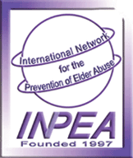
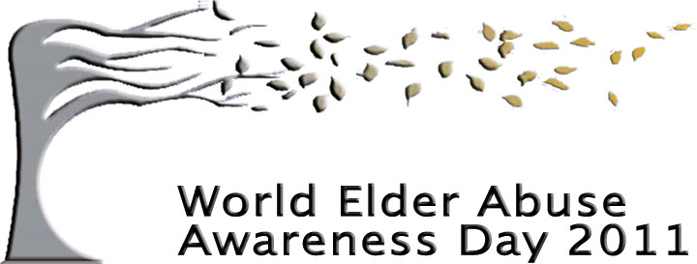
This is a text box to enter your specific information.

