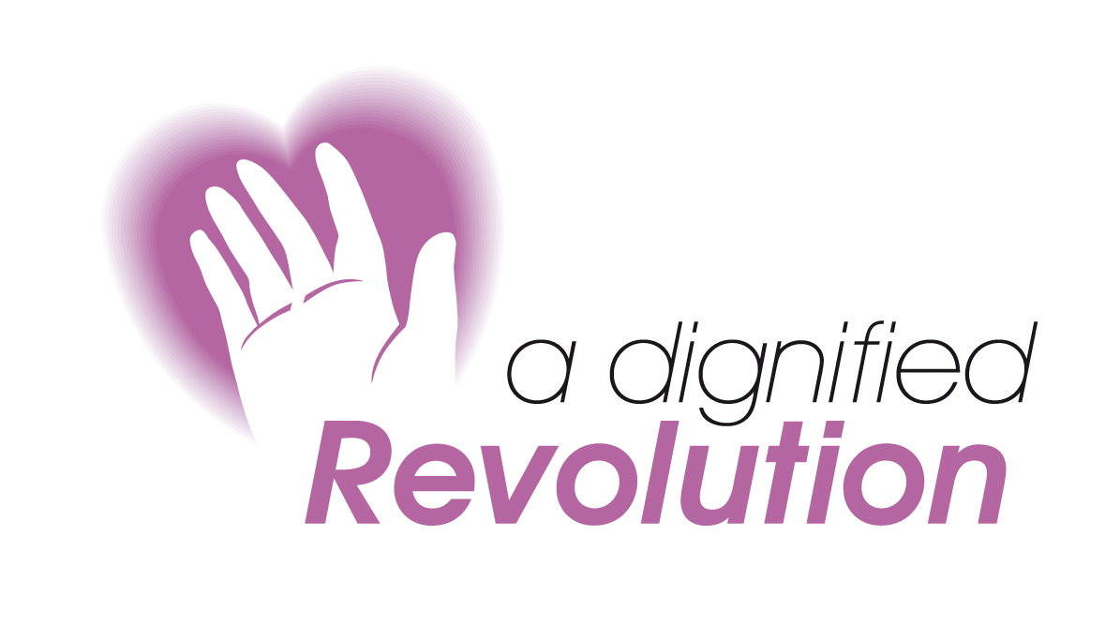

Using Human Rights to Maintain Dignity in Care Settings

Wednesday 10 November 2010
RNIB Cymru, Cardiff

Workshop Facilitator: Tessa Shellens,
Consultant Solicitor, Morgan Cole

The Human Rights Act aims to encourage Fairness, Respect, Equality, Dignity and autonomy for all. The principles underlying these rights reflect basic needs that enable us all to live full lives with maximum dignity and respect. These core values are at the heart of high quality health and social care and the act places a legal obligation on all public services to respect people’s human rights.
This workshop is relevant to anyone working in the health and social care environment. It is designed to develop your knowledge of the Act and demonstrate how you can use it to enhance the quality of care that you provide.
Learning Objectives

- Increased understanding of the Human Rights Act
- Developing a Human Rights approach to the care setting
- Using the Act to gain practical improvements in care

PROGRAMME
9.00 | Registration & coffee
9.30am | Welcome, introductions and expectations of the day
10.00am | My Human Rights – what do we mean and do we respect others?
 | Unpicking the Law: What is Human Rights Law and who does it affect?
11.00 | Break
 | Analysis of the Articles of the Convention. How can I use the articles to advocate the case for better care and respect?
12.30 | Lunch
1.30 | Devising a remedy: Human Rights as a practical tool for improving care. How can we reduce breaches and use the Human Rights Agenda to make a difference?
4.00 | Feedback and Close

Using Human Rights to Enhance Dignity in Care Settings

Wednesday 10 November 2010
RNIB Cymru, Cardiff

BOOKING FORM (please copy if more than one booking)

Name:
Job Title:
Department:
Organisation:
Address:
Tel:
Fax:
Email:
Special Requirements:

Fees
Fees are £135.00. An invoice will be raised on receipt of this booking form.
Please make cheques payable to A Dignified Revolution

Access:  We will do our best to ensure that everyone wishing to attend our events is able to fully participate. Prospective delegates with specific requirements should contact us at the earliest opportunity so that we can consider how we can best assist you. | Please post or fax this form to:  Monica Dennis  A Dignified Revolution  Britannia House  11 High Street  Cowbridge CF71 7AD  Tel: 07811 159800  Fax: 01446 774864  Email: info@dignifiedrevolution.org.uk  www.dignifiedrevolution.org.uk

This workshop can also be delivered as an in house event
For further details contact:
Monica Dennis: 07811 159 800

