3rd Annual Essay Competition 2010

World Elder Abuse Awareness Day (WEAAD) 2010

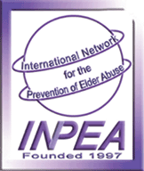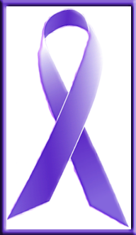

On the occasion of World Elder Abuse Awareness Day 2010, Silver Inning Foundation, a ‘Not for Profit’ dedicated organization for senior citizens and their family members will be commemorating Elder Abuse Day on 15th June’2010. It has taken the initiative to create awareness among civil society and Government to eliminate elder abuse at both micro and macro level.

SILVER INNING FOUNDATION invites an Essay of maximum 2000 words in following category and topics:

- For all age group:
‘Elders Abuse - The Change Has to Start at Our Home’

- For School Students - Class 5th to class 10th:
“My Grandparents - Our Golden Treasures”

- For Students - 1st year College to Post graduation :
'No Excuse for Elder Abuse - Signs and Solutions'

What is Elder Abuse?
Elder abuse is an under-recognized problem with devastating and even life-threatening consequences. Elder abuse is often defined as a single, or repeated act, or lack of appropriate action, occurring within any relationship where there is an ‘expectation of trust’ which causes harm or distress to an older person.

Types of Elder Abuse:
- Physical abuse
- Sexual abuse
- Emotional or psychological abuse
- Financial or material exploitation
- Neglect
- Abandonment
- Self-neglect

All of us know that we will be elders one day and join the ever increasing percentage of senior citizens in the global population! And yet some of us continue to show gross indifference and disrespect to our elders in our own families and in the society! Each of us might have countless reasons, logics and excuses for this behavior but this could be due to a combination of many problems. Let us try to put into a right perspective these various problems and what we could do to keep our elders happy.

Remember, by helping our elders stay physically fit and mentally happy, we are only helping ourselves and our future. If we fail to give proper care and respect to our elders at home now we will get the same ugly treatment from our children later on in our lives!

World Elder Abuse Awareness Day 15th June ,programme aims to increase society's ability, through various programmes to recognize and respond to the mistreatment of older people in whatever setting it occurs, so that the latter years of life will be free from abuse, neglect and exploitation.

Prizes:
The First (1st) best in each category will be given Prize of Rs.500/- by Indian cheque only each.

The Three (3) best essays in each category will be published on Website www.silverinnings.com as also on Blogs: http://peopleforsocialcause.blogspot.com/ ; http://silverinnings.blogspot.com/ And best Ten (10) in each category, with India postal address will be given Participation Certificate.

All the essays will be property of and used by Silver Inning Foundation as database/Talk / Reference / Lecture / Book/ Paper presentation for its strategy to Tackle Elder Abuse and issues od Elderly. The verdict of management of Silver Inning Foundation & Silver Innings for selection of best essay will be final.

Silver Inning Foundation consists of a dedicated team of professionals contributing to the cause of the elderly. Silver Inning Foundation conducts seminars, camps, lectures, awareness modules, advocacy, networking, Dementia management services and also has support groups for home based advice. At Silver Innings we are working towards creating Elder Friendly World where Ageing becomes a Positive and Rewarding Experience.

The Last date for submission of Essay is 10th June 2010.

Email your essay on or before 10th June 2010 to info@silverinnings.com and copy to silverinnings@gmail.com .

The winners will be announced online by email after 25th June 2010. For further information please call on Tel no. 09987104233 – Monday to Friday 10am to 5pm.

Terms and Condition:
- Essay should not be more than 2000 words
- Essay should only be in English language
- Essay should be sent by Email only (soft copy only)
- No hard copy will be accepted
- It’s open to all Indian Residence / POI / NRI
- People from other country can also participate, but they will not be part of competition.

This Programme is promoted by INPEA (International Network for Prevention of Elder Abuse) Indian Chapter through Development, Welfare and Research Foundation (DWARF) and 'Little Things Matter Initiatives' (LTMI).

Together, we all have the power to prevent elder abuse

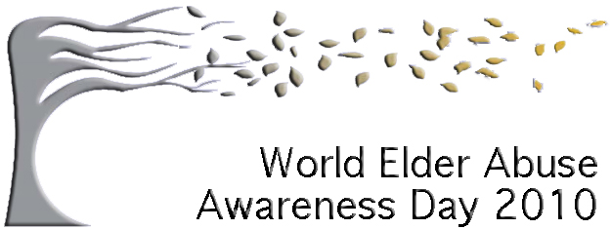
My World… Your World…Our World…Free of Elder Abuse

