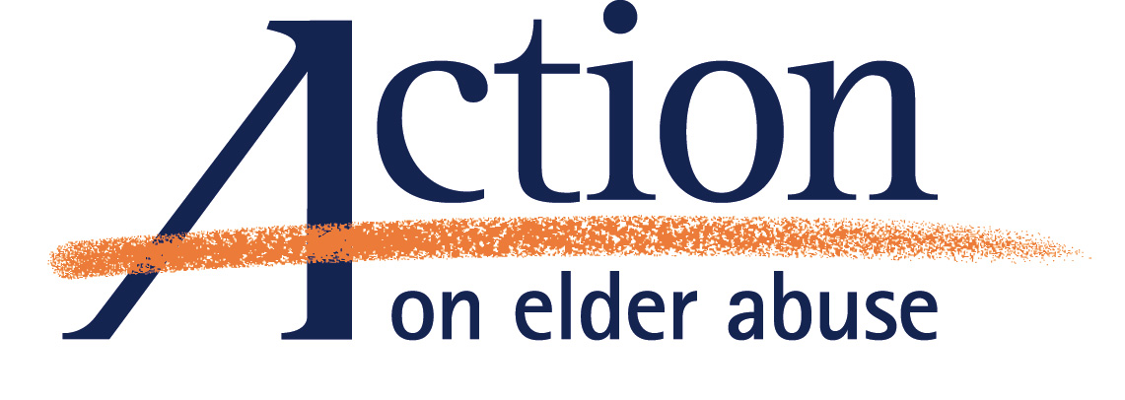
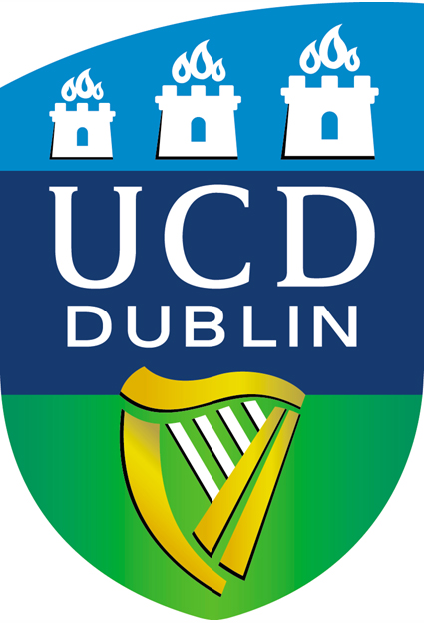
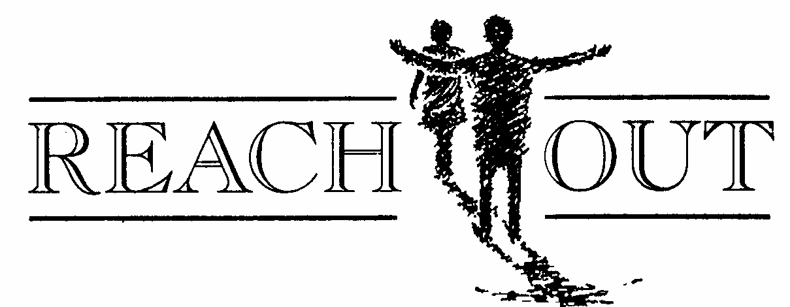

School of Nursing, Midwifery & Health Systems

Conference to Mark World Elder Abuse Awareness Day 2008
13th June 2008.

This conference explores the issue of elder abuse and looks at perspectives from the areas of research, practice and experience in the voluntary sector. This is an open conference which will be of interest to professionals who work with older people (nurses, doctors, social workers), voluntary agencies, the legal profession and policy makers Members of the public are also very welcome.

Speakers include:
Keynote Speaker: Brian Lenihan, Minister for Justice and Law Reform.
Mr. Gary Fitzgerald, CEO, Action on Elder Abuse, London.
Professor Pearl Treacy, School of Nursing, Midwifery & Health Systems, UCD
Ms. Bridget Penhale, School of Nursing, University of Sheffield

Ms Amanda Phelan, School of Nursing, Midwifery & Health Systems, UCD
Ms. Michele Clarke, Health Information and Quality Authority
Mr. Jack Keavney, REACHout
Ms. Lynn Phair, Consultant Nurse for Older people ( Safeguarding Adults)
West Sussex PCT

Attendance is free but registration is essential. Please register your interest with
Mr. Jack Keavney submitting your name, title (if applicable) and organization (if applicable).
Email: sote@eircom.net, Phone: 086 3250345

Venue: Lecture Theatre B004, School of Nursing, Midwifery & Health Systems, UCD.
(see: http://www.ucd.ie/visitors.htm . for maps & directions).
Registration: 9.30. Conference: 10am-4pm.

