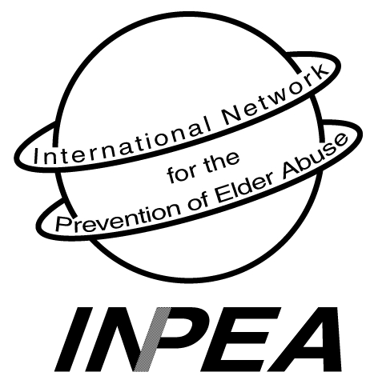

INTERNATIONAL NETWORK for the

PREVENTION OF ELDER ABUSE
222 College St. Suite 106 Toronto, Ontario, Canada M5T3J1
www.inpea.net



INPEA 2006 International Rosalie S. Wolf

Elder Abuse Prevention Memorial Award

It is with great pleasure that Dr. Lia Daichman and the Executives of INPEA announce the recipients of the 2006 Rosalie Wolf Memorial Elder Abuse Prevention Award (International Category) to Tawengwa M. Nhongo (Africa) and Jenny Liliam Andrade Palacios (Bolivia) representatives of of HelpAge International (HAI) of Africa and Latin America, for their contribution to the field of elder abuse, prevention and awareness and their incredible long standing work against discrimination, defending human rights and elders empowerment.

HelpAge International’s mission is to work with and for disadvantaged older people for lasting improvements in the quality of their lives. A core principal of this work is the promotion of the rights of older people through rights education with older people themselves, their families and local and national authorities. HAI in Latin America and Africa has a strong record of supporting and strengthening the organisation of older people for them to know, claim, exercise and defend their rights.

"HelpAge International es una red mundial de organizaciones sin fines de lucro con la misión de trabajar con y para las personas mayores en desventaja en todo el mundo con el fin de lograr una mejoría perdurable en la calidad de sus vidas."

INPEA EXECUTIVES:

PRESIDENT:
Dr. Lia Daichman
Buenos Aires, Argentina
liadaichman@fibertel.com.ar

VICE - PRESIDENT:
Dr. Elizabeth Podnieks
Ryerson University
Toronto, Ontario, Canada
onpea.info@utoronto.ca

SECRETARY GENERAL:
Susan B. Somers, JD
New York, USA sbsomers@aol.com

TREASURER:
Robert Brand, PhD
New York, NY USA
Brand@fordham.edu

SPECIAL OBSERVER:
Dr. Alex Kalache
World Health Organization
Geneva, Switzerland

SPECIAL ADVISORS:
Dr. Gloria Gutman
Simon Fraser University
Vancouver, B.C., Canada

Dr. Tomas Engler
Interamerican Development Bank (IADB)
Washington, D.C., USA

INPEA REGIONAL REPRESENTATIVES:
AFRICA:
Monica Ferreira, D.Phil.
Cape Town, South Africa
mf@cormack.uct.ac.za
ASIA:
Toshio Tatara, PhD.
Chiba, Japan
ttatara@beige.ocn.ne.jp

EUROPE:
Prof. Ariela Lowenstein
Tel: 972-4-8240815
Fax: 972-4-8240573
ariela@research.haifa.ac.il

LATIN AMERICA:
Susana Aguas, Psych.
Buenos Aires, Argentina
seaguas@yahoo.com.ar

NORTH AMERICA:
Betty Malks, MSW, CSW
San Jose, Ca., USA
Betty.Malks@ssa.sccgov.com

OCEANIA:
Dr. Susan Kurrle
Hornsby, Australia
skurrle@doh.health.nsw.gov.au

UN NGO Representative:
Patricia Brownell, Ph.D
New York City, NY, USA
Brownell@fordham.edu

