
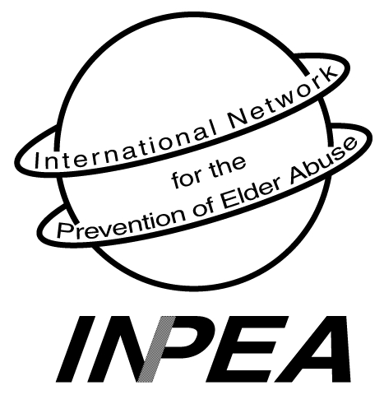

INTERNATIONAL NETWORK for the

PREVENTION OF ELDER ABUSE
INPEA EXECUTIVES:

PRESIDENT:
Dr. Lia Daichman
Buenos Aires, Argentina
liadaichman@fibertel.com.ar

VICE - PRESIDENT:
Dr. Elizabeth Podnieks
Ryerson University
Toronto, Ontario, Canada
onpea.info@utoronto.ca

SECRETARY GENERAL:
Susan Somers
New York, USA
sbsomers@dfa.state.ny.us

TREASURER:
Glenda Callanen
Santa Monica, CA, USA

SPECIAL OBSERVERS:
Dr. Alex Kalache
World Health Organization
Geneva, Switzerland

Dr. Martha Pelaez
Pan American Health Organization
Washington, D.C., USA

Dr. Mark Gorman
HelpAge International
United Kingdom

SPECIAL ADVISOR:
Dr. Gloria Gutman
Simon Fraser University
Vancouver, B.C., Canada

INPEA REGIONAL REPRESENTATIVES:

AFRICA:
Prof. Nana A. Apt
University of Ghana
napt@ashesi.edu.gh

ASIA:
Dr. Toshio Tatara
Chiba, Japan
ttatara@beige.ocn.ne.jp

EUROPE:
Bridget Penhale
Hull, United Kingdom
B.L.Penhale@hull.ac.uk

LATIN AMERICA:
Laura Machado
Rio de Janeiro, Brazil
Lmachado@attglobal.net

NORTH AMERICA:
Susan Aziz
Boynton Beach, FL, USA
saziz@adelphia.net

OCEANIA:
Dr. Susan Kurrle
Hornsby, Australia
skurrle@doh.health.nsw.gov.au

It is with the utmost pleasure that INPEA is pleased to name Dr. Lia Daichman as this year’s recipient of the Rosalie Wolf Memorial Award. The award is presented at an international level, annually by INPEA and the Family Violence & Sexual Assault Institute (FVSAI) to “an individual who has demonstrated dedication and commitment to the ideals of Rosalie Wolf to prevent and reduce elder abuse and promote awareness through one or more of the following: research, education, policy, practice.” Lia Daichman exceeds all of these criteria.
Following the untimely death of Rosalie Wolf in 2002, Dr. Lia Daichman became the President of the International Network for the Prevention of Elder Abuse. Since that time there has been amazing growth within the Network and its position in the global context of human rights. Under Lia’s leadership, the Network has become a Standing Committee of the International Association of Gerontology (IAG) and, more recently, obtained official status as a NGO on the Economic and Social Council of the United Nations. Membership has increased to 525 people including 35 National Representatives.
ANNOUNCING

Rosalie Wolf Memorial Award, 2004 Recipient
Dr. Lia Daichman


Lia Daichman

Lia is a practicing Geriatrician and Professor of Medicine at both the University of Belgrano and National University of Buenos Aires in Argentina. She has successfully combined a brilliant medical career with the far reaching and numerous activities of INPEA. She is a pioneer in examining the relationship of self-neglect to elder abuse. Lia reminds us all of the ongoing need to evaluate ethical tensions in working with older abused persons and their perpetrators. The esteem with which Lia is held within the medical profession is seen by her frequent invitations to deliver keynote and guest lectures within Argentina and elsewhere.
Few are aware of Lia’s personal philanthropy. She has donated funds, computers, books, and other materials to needy hospitals and organizations around the world. And on many occasions, she has generously sponsored INPEA members and other NGOs to attend important elder abuse conferences.
Lia is passionate about the issue of elder abuse prevention. Her loyalty to her friends is legendary; her love for her children is boundless. No matter where she is in the world, they are always in her heart and on her cell phone!
Lia’s most amazing accomplishment took place this past month in Cuba. She and Dr. Emilio Zayas Somoza successfully launched the first ever “Train-the-Trainer” seminar on “Health and Human Rights Issues Related to Elder Abuse and Neglect” in partnership with the Cuban Society of Geriatrics and Gerontology.
The Executive is proud and honored to present Dr. Lia Daichman as the 2004 recipient of the Rosalie Wolf Memorial Award. She has taken INPEA to new heights. With her dazzling smile, she lights up a room and is easily the most recognizable champion of elder abuse and human rights within the international community.

Elizabeth Podnieks, Vice President
Susan B. Somers, Secretary General
May 11, 2004

