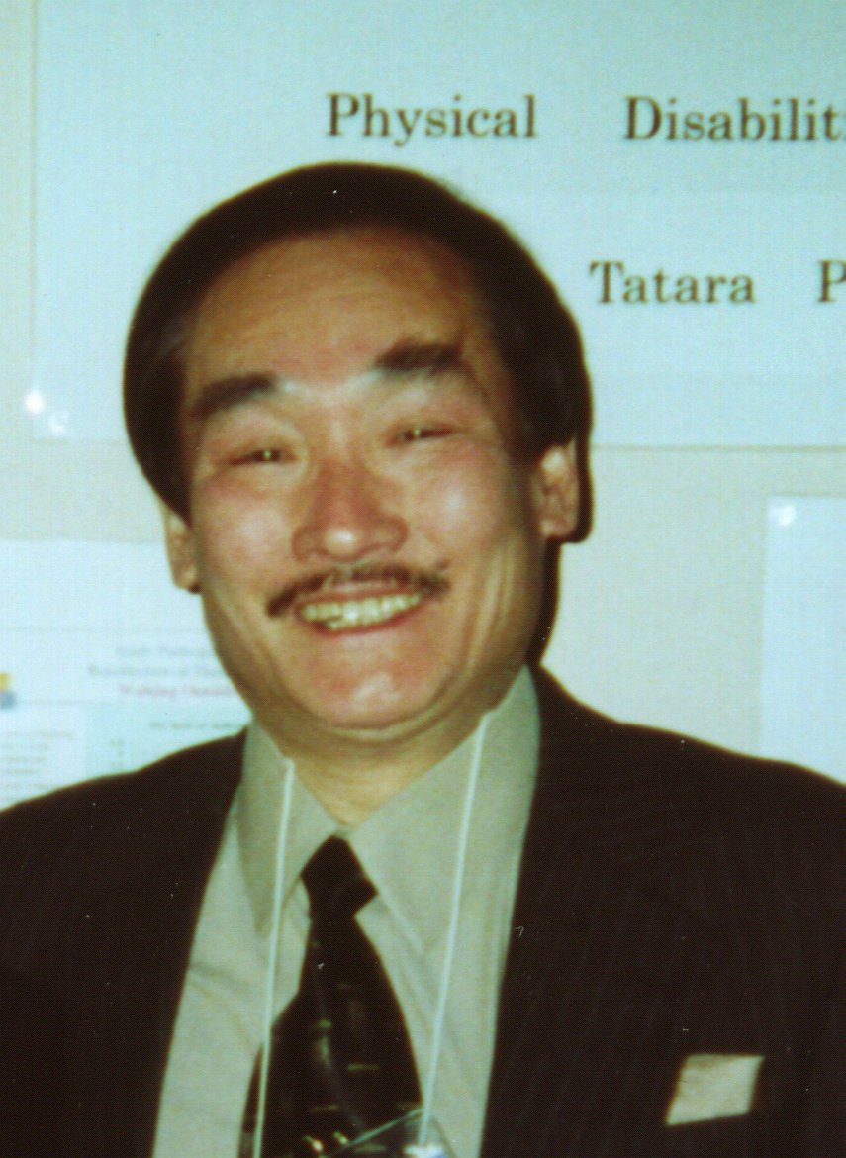
Biographic Information

Toshio Tatara, Ph.D. is a professor of social welfare at the Shukutoku University College and Graduate School of Integrated Human and Social Welfare Studies in Chiba, Japan. He is the director of this university’s Social Welfare Research Institute. Prior to moving back to Japan to accept the current position in April 1998, he was a child welfare supervisor at the Jackson County Department of Social Services in Wisconsin (July 1969 to August 1970); was a lecturer at the Bryn Mawr College Graduate School of Social Work and Social Research (October 1972 to May 1976); was a senior research associate (October 1976 to September 1977) and the director of the Research and Demonstration Department at the American Public Welfare Association (APWA) (From October 1977 to March 1998), which became the American Public Human Service Association (APHSA) in 1998; and served as the director of the National Center on Elder Abuse (NCEA) (October 1988 to March 1998), which was created by U.S. Congress and the U.S. Administration on Aging (AoA).

An R&D administrator, researcher, and educator with more than 30 years of professional experience in the human services field, Dr. Tatara has directed nearly 50 research, demonstration, evaluation, and training projects of national significance in the United States and Japan; presented papers at many national and international conferences; served as a technical consultant for the federal government, state and local governments, and professional organizations; and testified several times before Congress. In addition to more than 30 technical reports and monographs that he has written for federal and state agencies and various funding organizations, Dr. Tatara is the author of over 60 articles, book chapters, and books published in the United States and Japan. His recent major publications include: Characteristics of Children in Substitute and Adoptive Care: A Statistical Summary of the VCIS Data, published by APWA in 1993; An Analysis of State Laws Addressing Elder Abuse, Neglect, and Exploitation, published by NCEA in 1995; and Understanding Elder Abuse in Minority Populations, published by Taylor & Francis in 1998. In Japan, he has published a total of nine books and nearly 30 articles, to date, and the English titles of some of these Japanese-language books are: How the U.S. has Addressed the Problem of Elder Abuse (1994), An Analysis of Social Welfare Policies and Programs during the Allied Occupation of Japan (1997), and The Standards of Practice and Certification Rules for Case Management in the U.S. (2000), all of which were published by Tsutsui Shobou Publishing Co.; Elder Abuse: The Extent of the Problems and Major Issues (2001 and 2002) and Assessing Satisfaction in Health and Long-Term Care—A Practical Approach to Hearing the Voices of Consumers (the Japanese translation) (2002), both of which were published by Chuo Hoki Publishing Co.; and Elder Abuse Programs in the World –America, Australia, Canada, Norway, and Latin American Countries (the Japanese translation), published by Akashi Shoten Publishing Co. in 2004.

Over the years, Dr. Tatara has served on the advisory boards of federal and state agencies, and national organizations, as well as on the editorial boards of a number of professional journals. Between 1986 and 1997, he was the vice chair and chair of the Board of Directors of the International Council on Social Welfare (ICSW)/U.S. Committee. Additionally, appointed by the U.S. Administration on Aging (AoA), he was an official delegate for the 1995 White House Conference on Aging. Dr. Tatara was one of the founders of the International Network for the Prevention of Elder Abuse (INPEA) in 1997 and has served as a member of the Executive Committee on their Board of Directors. He has been an active member of the Gerontological Society of America (GSA), and has served as the chair of their discussion group on elder abuse, neglect and exploitation. Further, he has been on the Board of Consulting Editors for the Journal of Elder Abuse & Neglect since the inception of this journal in 1989. In Japan, Dr. Tatara contributed to the establishment of the Japan Academy for the Prevention of Elder Abuse (JAPEA) in 2003, and has been serving on their Board of Directors in charge of the Research Committee, as well as the International Exchange Committee. He also is on the Board of Directors for the International Council on Social Welfare (ICSW)/the Japanese National Committee. Additionally, Dr. Tatara has received funding from the Japanese Ministry of Health, Labour, and Welfare, since 1998, to conduct various types of research projects in elder abuse. In 2003, he was named by this Ministry to serve as the chair of the Technical Advisory Committee for Japan’s first national study of elder abuse.

Dr. Tatara received a B.A. in Humanities, in 1960, from Kwansei Gakuin University in Hyogo, Japan and a Master’s degree in Social Work (MSW), in 1969, from the George Warren Brown School of Social Work at Washington University in St. Louis, Missouri. He was chosen as one of the three most outstanding alumni of this graduate school for 1995. Further, he received his Doctorate in Philosophy (a Ph.D.) in Social Welfare and Social Research from Bryn Mawr College in 1975. Dr. Tatara was on the faculty of Bryn Mawr College for four years before joining APWA in 1976. Finally, upon taking an early retirement from APWA in March 1998, Dr. Tatara was given APWA’s highest award, “Leadership Award,” in recognition of his contributions to the field of human services research in the U.S. for the previous 25 years.
July 1, 2005

