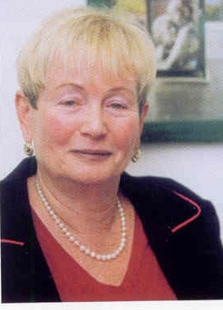
Ariela Lowenstein is Full Professor, Graduate Department of Aging Studies and Head, Center for Research and Study of Aging, Faculty of Welfare and Health Sciences, University of Haifa, Israel. She also heads a Center of Excellence on Aging and Migration.

She has close research collaboration with scholars from the US, Canada, Europe, and Latin America.

She publishes extensively in prestigious journals, book chapters, monographs and training manuals, having published more than 150 publications. She has also written two books in Hebrew, and is co-editor of three books in English. She is the recipient of numerous competitive research grants, prestigious scholarships and awards, and served as the Research Coordinator of a large scale 3 years EU project (OASIS- “Old Age and Autonomy: The Role of Service Systems and Intergenerational Solidarity”). Currently she is the principal investigator of a large US-Israel study, funded by the Bi-National Science Foundation on comparing family relations in Israel and the US.

Lowenstein is reputed as one of the leading national and international experts in aging. She is the past chair of the European Behavioral, Social Science and Research Section of the International Ass. of Gerontology – European Region, and served for five years as chair of the Israeli Gerontological Society, where she recently received a prize for life achievement. She is an Honorary Fellow of the Gerontological Society of America. She is a board member of the International Federation on Aging (IFA) and European Regional representative of the International Network for the Prevention of Elder Abuse (INPEA).

She has extensive experience as an editorial board member for a number of journals and for various foundations (e.g. GIF, American National Science Foundation and WHO). She also serves on various Israeli governmental and local agencies as consultant, member of various national committees and an advisor for policy.

She has a Masters of Public Administration from New York University, N.Y. and a Ph.D. in Sociology from the Hebrew University in Jerusalem.

Her research areas are: intergenerational family relations, elders’ quality of life, policy development and service evaluation, elder abuse, theory building, grandparenthood, family caregiving, gerontological education.

