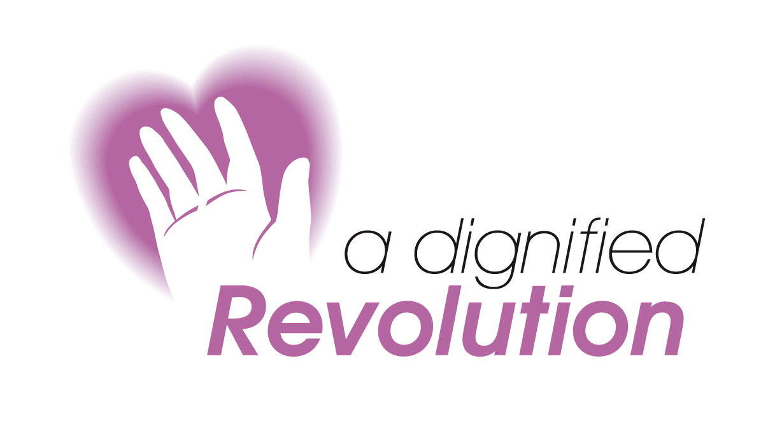

Dignified Care Despite Difficult Colleagues

Tuesday 5 April 2011
Cowbridge, Vale of Glamorgan

Patient care and quality can be compromised when carers and professionals display bullying, manipulative, intimidating and negative behaviours. In addition, you can feel de-motivated, stressed and distracted. This course will help you how to look differently at the situation and, therefore, deal with it more effectively to improve dignity and respect in the care environment.

Learning Objectives:
- Understand personality disorders and social psychopathy
- Be able to spot the warning signs
- Develop practical actions
- Learn what you should not do
- Appreciate that the perpetrator needs help

Feedback
- Extremely helpful to share and network with a diverse group of colleagues who are all facing similar challenges with difficult colleagues
- All of it was very interesting indeed - food for thought
- It was reassuring to hear other people's experiences and to realise I am not alone
- Gave me insight into why people behave the way they do and that it is not always mindful arrogance
- Protected time for reflection and sharing problems – excellent

PROGRAMME
9.00 | Registration & coffee
9.30 | Stress and bullying in the care environment
10.30 | Emotional intelligence
11.30 | Personality disorders and bullying
12.30 | Communication barriers and listening
1.00 | Lunch
2.00 | Assertiveness
2.30 | Coping with difficult colleagues
4.00 | Other responses
4.30 | Close

The knowledge gained from this event will meet the requirements of the
NHS Knowledge & Skills Framework (NHS KSF)

Dignified Care Despite Difficult Colleagues

Tuesday 5 April 2011
Cowbridge, Vale of glamorgan

BOOKING FORM (please copy if more than one booking)

Name:
Job Title:
Department:
Organisation:
Address:
Tel:
Fax:
Email:
Special Requirements:

Fees
Fees are £135.00. An invoice will be raised on receipt of this booking form.
Please make cheques payable to A Dignified Revolution

Cancellation Policy
Bookings can be cancelled for a full refund if received in writing or by email 14 days before the event. There are no refunds after that date and outstanding invoices must be settled even if the place is not taken. Substitutes are permitted at any time

Access:  We will do our best to ensure that everyone wishing to attend our events is able to fully participate. Prospective delegates with specific requirements should contact us at the earliest opportunity so that we can consider how we can best assist you. | Please post or fax this form to:  Monica Dennis  A Dignified Revolution  Britannia House  11 High Street  Cowbridge CF71 7AD  Tel: 07811 159800  Fax: 01446 774864  Email: info@dignifiedrevolution.org.uk  www.dignifiedrevolution.org.uk

Protected time for reflection and sharing problems – excellent

Very helpful to share and network with a diverse group of colleagues who are all facing similar challenges with difficult colleagues

This workshop can also be delivered as an in house event
For further details contact:
Monica Dennis -07811 159800

